# Longitudinal data:

* Measures close together in time will be closer: week measures closer than month measures; We can check this using cor();
* Intercept represents all variables when the time = 0;
* Intercept represents difference in outcome when time = 0;
* Look table below:
  + ENDO x EXO:
  + As ENDO is defined the **reference is EXO**, so EXO starts with 22.47 (intercept)
  + Endo = intercept + slope => 22.47 + 1.98

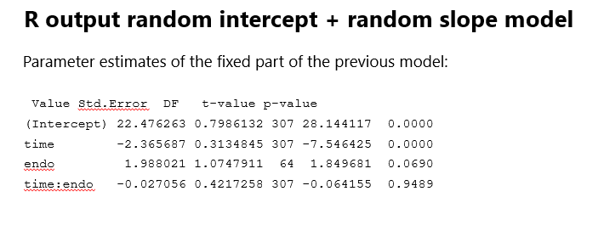

## LMM VAR – COR Matrix

* Model correlation of measurements *implicitly*
* Random intercept model implies a compound symmetry structure
* Random intercept and random slope also implies a certain correlation structure for the data => no simple structure
* structure depends on the estimates for ${σ_{}}^{2}$, ${σ_{1}}^{2}$, and $σ_{}$, but *usually* the variances increase for later time points and correlations decrease when time points are further apart

## CPM VAR-COR MATRIX (covariance pattern model or GEE-type cov structures)

* No random effects
* Residuals are not independent => corr for ∑
* Var-cor (something complicated)
* Model correlation of measurements *explicitly*

1. Independent correlation structure
2. Compound symmetry correlation structure
3. Unstructured
   1. Var at each time point different
   2. Very expensive (cost a lot of degree of freedom)
4. Autoregressive of order 1: AR(1) (homogeneous)
   1. Assumes all observations 1 time unit apart have same correlations (p), 2 units corr ($p ^2)$, and so on…
   2. Decreasing correlation over time.
5. Autoregressive of order 1: AR(1) (Heterogeneus)
   1. Allow var to differ over time
   2. Fits the data better

# Summary

* Longitudinal data is a specific form of multilevel data
  + measurements within patients, challenge is in modelling time properly
* Time can be continuous or discrete
  + discrete: everyone measured at a few specific time points
    - but, with 3+ measurements per person and approximately linear time trends, you could still consider modelling data as continuous
  + continuous: measurements at different times for different individuals
* We can account for correlation of measurements over time
  + explicitly: variance-covariance matrix of residuals (CPMs)
    - primarily when everyone (theoretically) measured at same time points
  + implicitly: random intercept, random slope for time (LMEs)
  + (both explicitly & implicitly: LMEs with autocorrelated errors)
* “Baseline” measurement of outcome has different meaning depending on study design